
E/0 8600
DATA SHEET

GENERAL CHARACTERISTICS:
All position AC/DC coated electrode, depositing high alloy weld metal, designed to produce crack-free deposits having very high mechanical properties. Specially formulated high-alloy electrode for welding dissimilar, unknown, and problem steels. Superior performance of limited input AC welding machines. Highly alloyed special manual electrode for joining a broad range of difficult to weld metals including austenitic-manganese, air-hardening and high-carbon steels, and for joining dissimilar joining.

APPLICATIONS:
- GOOD FOR ALL ALLOY & CARBON STEELS - low-medium-high in all positions, under all conditions, including dissimilar combinations.
- Weld all tool steels, manganese steels and specialty steels in thick-to-thin designs.
- Will deposit using non-commercial AC or DC power sources having very low open circuit voltage characteristics.
- Drag or touch welding technique may be used, particularly in fillets without slag interference.

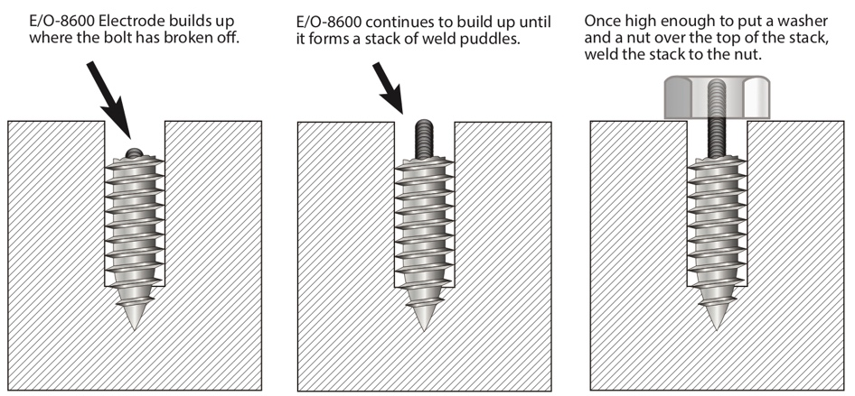
MECHANICAL PROPERTIES:
- Tensile/Yield Strength: 120K / 79K PSI
- Hardness: 90 HRB
- Current Polarity: DCEP (+) AC (-)
- Electrode Size: Amperage:
1/16” 25-55
3/32” 55-70
1/8” 75-95
5/32” 90-115
3/16” 135-190

PROCEDURE:
Clean surface and deposit electrode maintaining short to medium arc length. Tilt electrode 15° in direction of travel. For rapid filleting, raise amperage slightly and drag weld, inclining the electrode 45° in the direction of travel. Back-whip craters and remove slag between passes. Note: For max. strength, use straight stringer beads, chip slag between passes.

